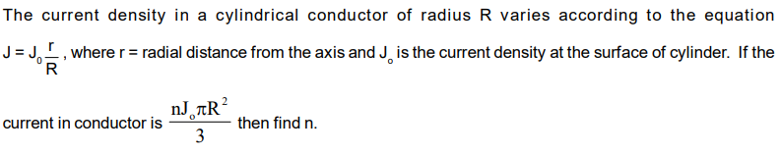

**Answer and Hint**

Ans: 2

Consider an infinitesimal element of the cylinder of width ‘dr’. Then integrate over the whole cylinder using dI = J(r).2.pi.r.dr with the limits from 0 -> R.